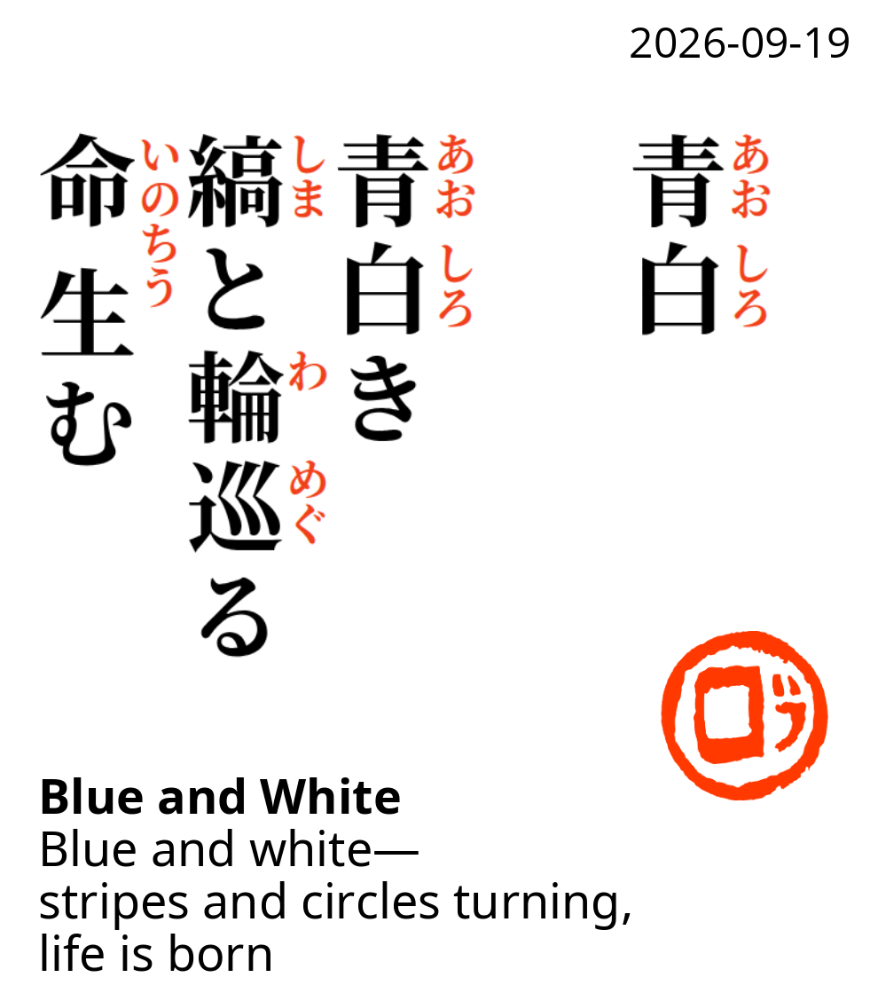 | Your mother exercising on the exercise bike, wearing a blue-and-white striped shirt. The lines and circles from the wheels create a very nice sense of motion and contrast. The exercise will help maintain and demonstrate her good health.
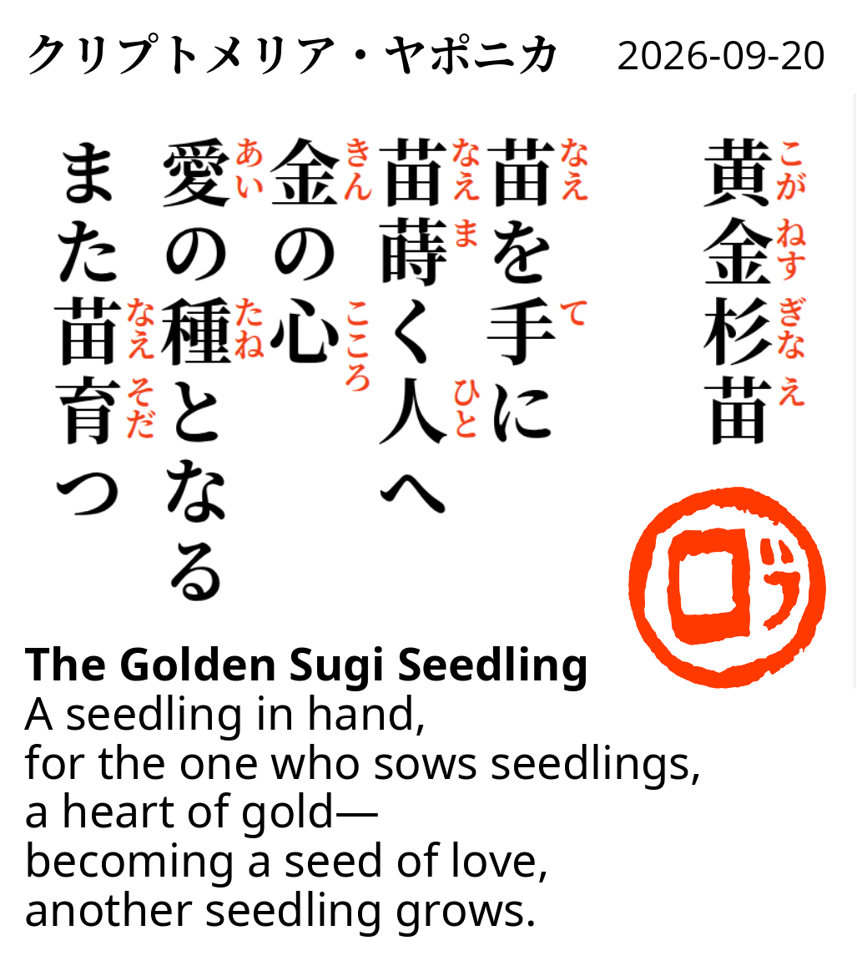 | I gave your mother a seedling of Cryptomeria japonica (Sugi tree). The seedling is a symbol of how your mother has “seeded” two beautiful daughters, who in turn become seeds for other golden seeds, like your son, to be born and nurtured. Just as a seed grows into a Sugi tree, a mother’s love and life continue through the generations.
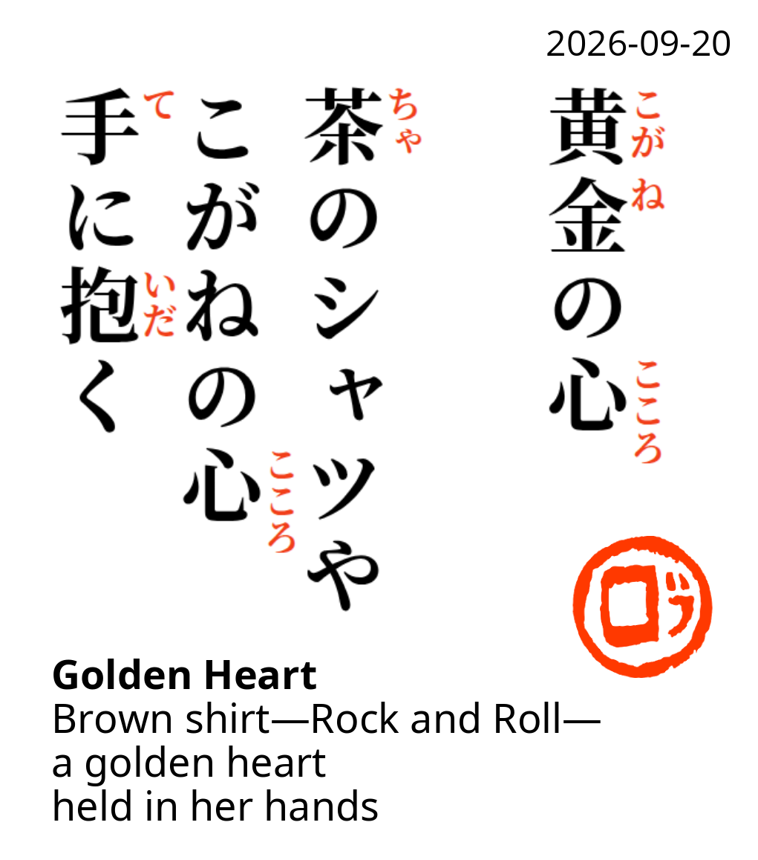 | The same scene as above, but from a different angle. Your mother is wearing a brown T-shirt with “Rock and Roll Cafe” written on it. But what she is holding is the golden heart — a symbol that has represented your grandmother to me for the past ten years. The golden heart now follows the three generations of women in your family.

